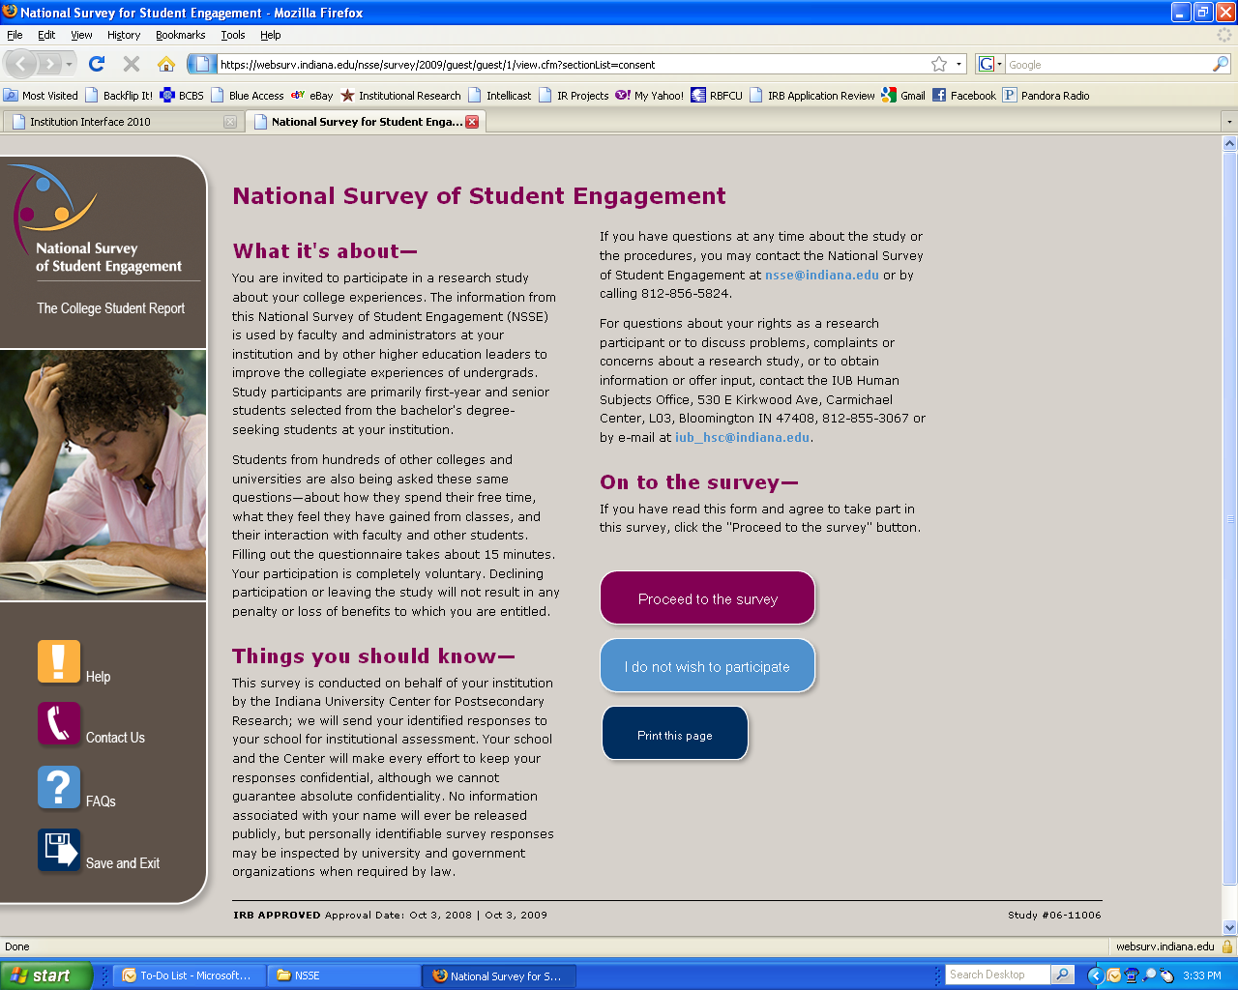

**Note: NSSE logo on left will be replaced with Texas State University-San Marcos logo on actual web page.**